**LAB PROD CIMB GCP**

Topology

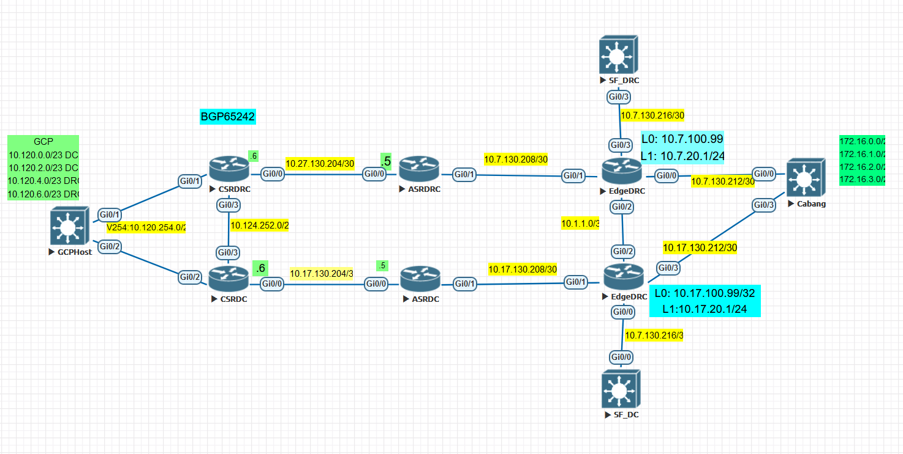

IP Address and Requirements

1. GCP Host have default route to both CSR DRC and CSR DC in real environment
2. GCP Subnet 10.120.0.0/23 and 10.120.2.0/23 should be advertised via DRC only.
3. GCP Subnet 10.120.4.0/23 and 10.120.6.0/23 should be advertised via DC only.
4. IP Cabang = 172.16.0.1/24, IP DRC 10.7.20.1/24, IP DC: 10.17.20.1/24
5. IP SLA 1 from CSR DRC (10.124.255.2/32) and CSR DC (10.124.255.3) icmp echo to Edge DC Loo0: 10.17.100.99/32
6. IP SLA 2 from CSR DRC (10.124.255.2/32) and CSR DC (10.124.255.3) icmp echo to Edge DC Loo0: 10.7.100.99/32
7. CSR DRC Filtered out 10.17.100.99/32 from ASR DRC, CSR DC Filtered out 10.7.100.99/32 from ASR DC, so when a Link Down, IP SLA is not pinging Edge from next hop peer CSR.
8. There is possibility to add both 2 Edge in **set ip next-hop** using 2 sequences per route-map (Not Tried Yet)
9. PBR at CSRDRC is applied at G0/1 and G0/3. PBR at CSRDC is applied at G0/2 and G0/3.

**Proofing**

1. **Static Route GCP Host to CSR DRC Only (G0/1: 10.120.254.2):**

Initial Setup at GCP Host:



* 1. 10.120.0.1 to 10.7.20.1 should go through DC

Traffic is flowing From GCP Host -> CSR DRC -> CSR DC -> ASR DC -> Edge DC -> Edge DRC

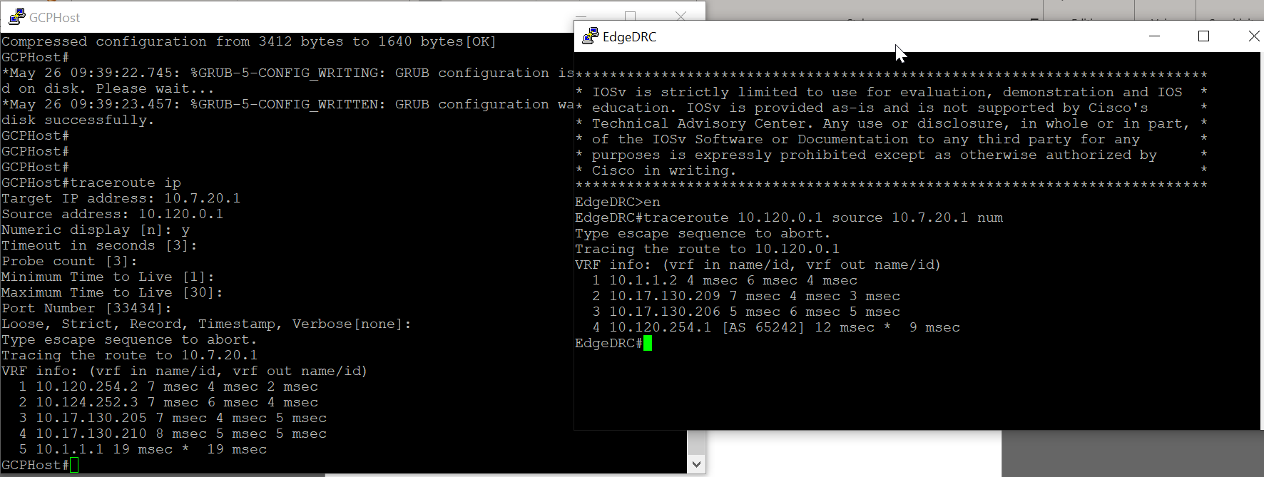

* 1. 10.120.4.1 to 10.7.20.1 should go through DRC

Traffic is flowing From GCP Host -> CSR DRC -> ASR DRC -> Edge DRC

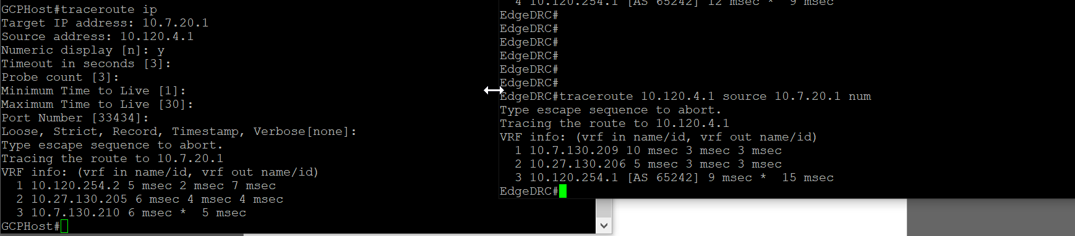

* 1. 10.120.0.1 to 10.17.20.1 should go through DC

Traffic is flowing From GCP Host -> CSR DRC -> CSR DC -> ASR DC -> Edge DC

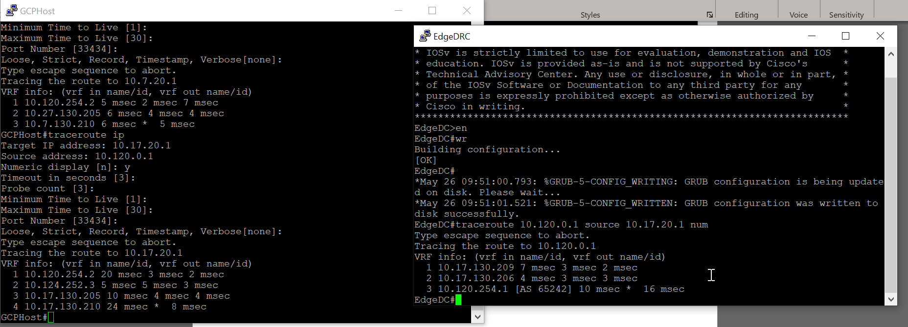

* 1. 10.120.4.1 to 10.17.20.1 should go through DRC

Traffic is flowing From GCP Host -> CSR DRC -> ASR DRC ->Edge DRC-> Edge DC

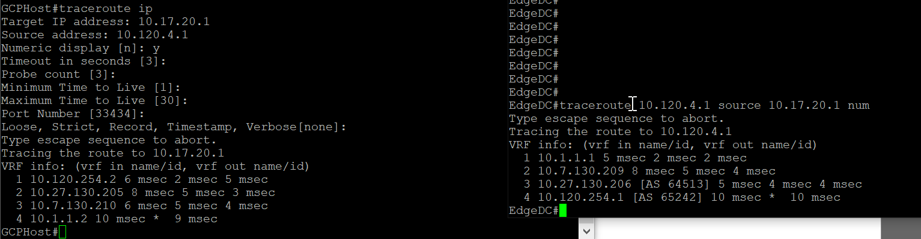

1. **Static Route GCP Host to CSR DC Only (G0/2: 10.120.254.3):**

Initial Setup at GCP Host:



* 1. 10.120.0.1 to 10.7.20.1 should go through DC

Traffic is flowing From GCP Host -> CSR DC -> ASR DC -> Edge DC -> Edge DRC

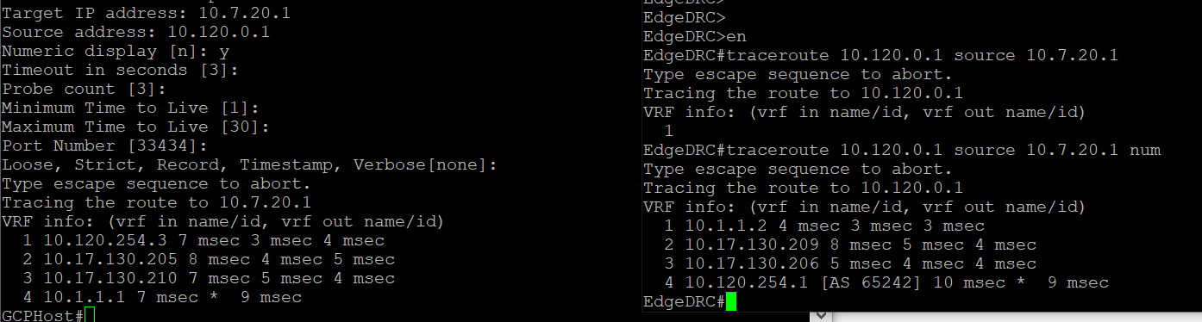

* 1. 10.120.4.1 to 10.7.20.1 should go through DRC

Traffic is flowing From GCP Host -> CSR DC -> CSR DRC -> ASR DRC -> Edge DRC

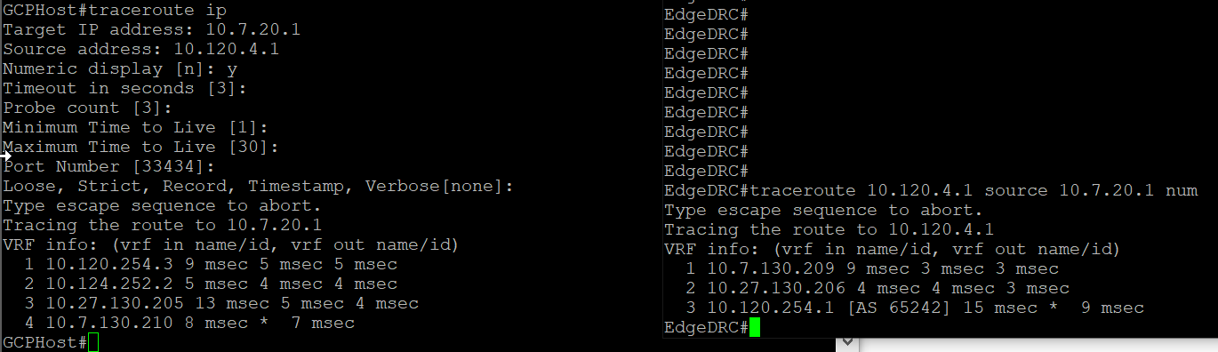

* 1. 10.120.0.1 to 10.17.20.1 should go through DC

Traffic is flowing From GCP Host -> CSR DC -> ASR DC -> Edge DC

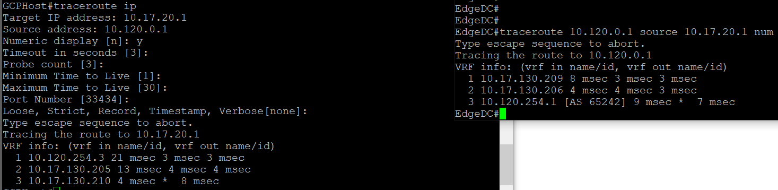

* 1. 10.120.4.1 to 10.17.20.1 should go through DRC

Traffic is flowing From GCP Host -> CSR DC -> CSR DRC -> ASR DRC ->Edge DRC-> Edge DC

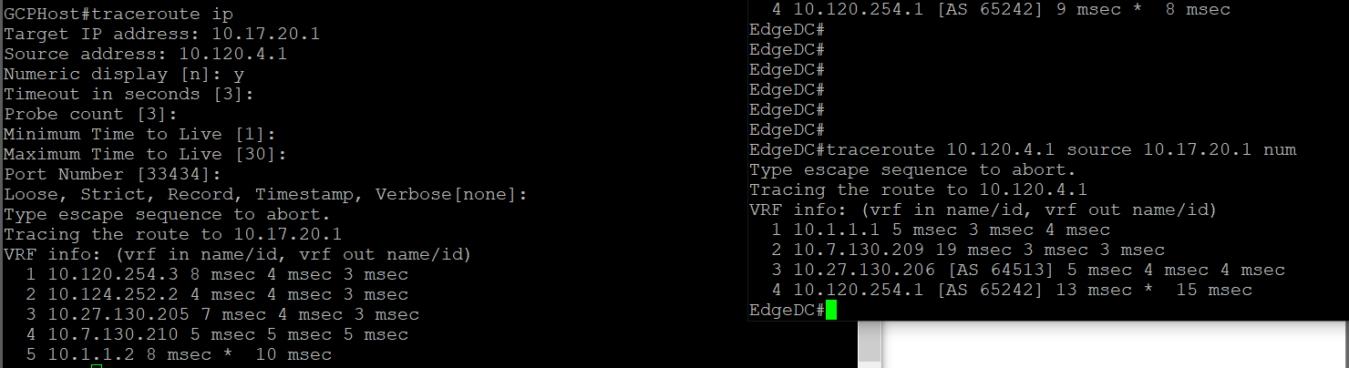

**FAILOVER TEST MAIN LINK DRC[10.120.4.1 to 10.7.20.1] (GCP Host Buang ke CSR DC)**

1. Test Already occur, when main link down (DRC) , 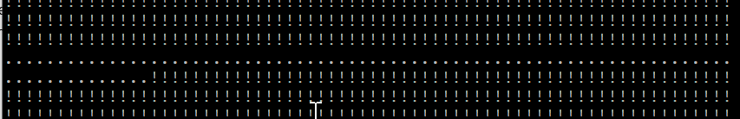

it will have downtime for about 3 minutes, and then traffic resumed using secondary link (DRC)

1. **However** link recovery is very fast and less than 3 sec



**FAILOVER TEST MAIN LINK DRC [10.120.4.1 to 10.7.20.1] (GCP Host Buang ke DRC)**

1. When Main link DRC Down:

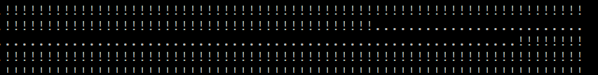

1. When Main link DRC UP doesn’t show downtime (very minimal)

**FAILOVER TEST MAIN LINK DC [10.120.0.1 to 10.17.20.1] (GCP Host Buang ke DRC)**

1. **When Main Link DC Normal: via DC**

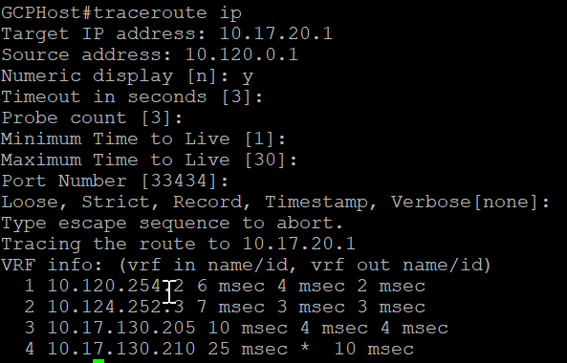

1. **When Main Link DC Down:** Packet is forwarded via GCP

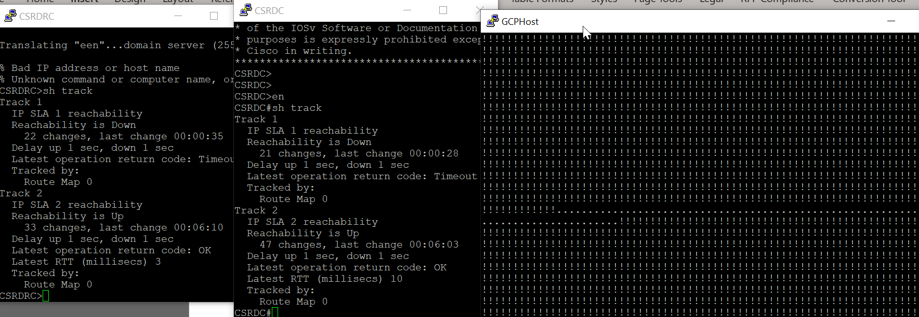

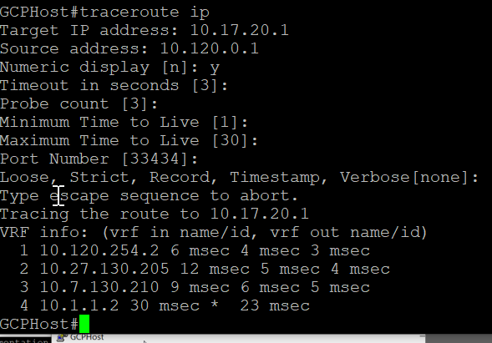

1. **When Link Recovered: only 1 packet loss. It backs to forward into DC**

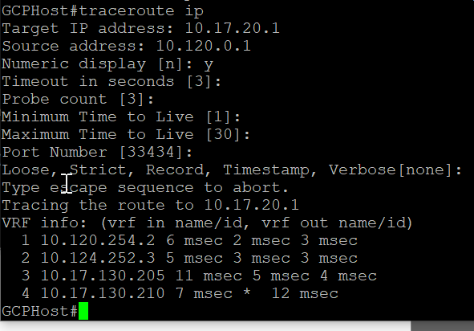

**FAILOVER TEST MAIN LINK DC [10.120.0.1 to 10.17.20.1] (GCP Host Buang ke DC)**

1. **Normal Condition:** Flow through DC

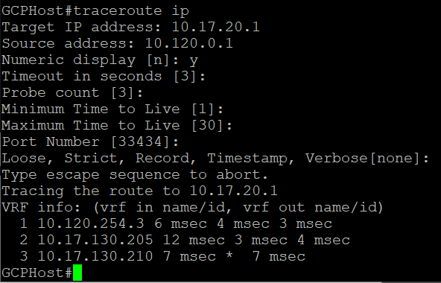

1. **When main link DC down:** It flow through DRC

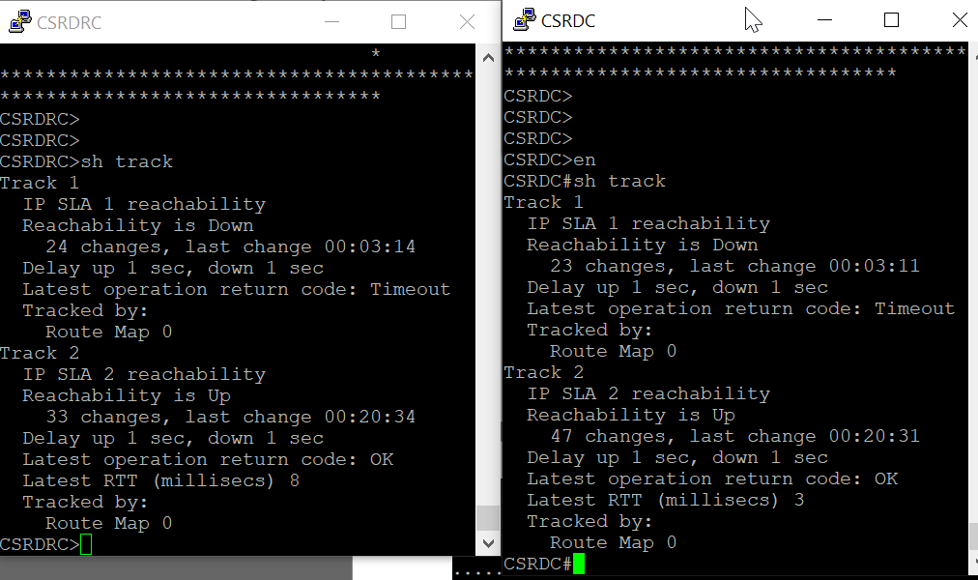

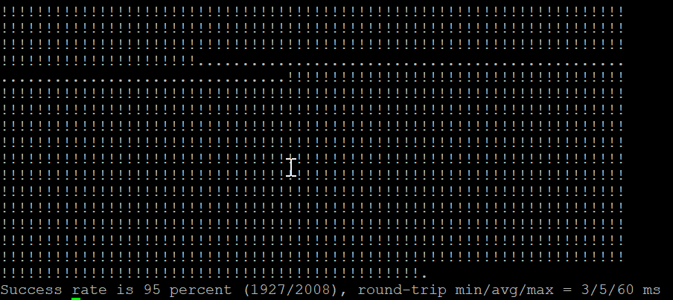

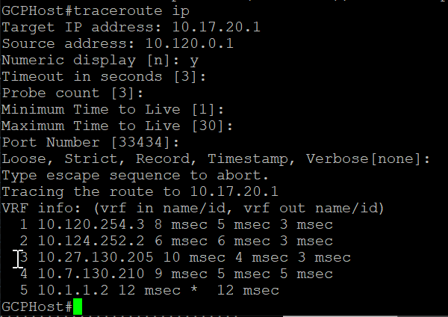

1. **When DC link recovered:** Loss only Few Packets. Forwarding back through DC

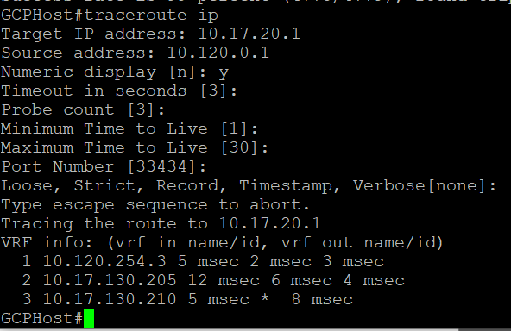

**CONCLUSION**

1. **BFD Should be configured between Edge and ASR (else it will be converged in 3 minutes) because it’s not directly connected.**
2. **PBR is succeed in CSR side**